Game Design Document

Fill up the Following document

1. Write the title of your project.

Clean your area!

1. What is the goal of the game?

To make people enthusiastic against cleaning their town.

1. Write a brief story of your game?

The story is that you are on a mission to keep your city clean and neat. It works in the following ways like you have to shoot yourself while picking up the garbage and put that video on our app.

It will be analysed by our panel of experts and then if its real you will

earn points and badges .

1. Which are the playing characters of this game?

* Playing characters are the ones which respond to the user based on the input from the user
* Cars, monkeys, dinos, wizards etc, are the playing characters in the game.

|  |  |  |
| --- | --- | --- |
| Number | Character Name | What can this character do? |
| 1 | The character name will be set by user. | Since this is an character of user it can post videos of cleaning their city. |

1. Which are the Non Playing Characters of this game?

* Non Playing characters are the ones which don't have an action or a behaviour when the user interacts with the game.
* Hurdles, stones, bananas, coins, etc are non playing characters in the game.

|  |  |  |
| --- | --- | --- |
| Number | Character Name | What can this character do? |
| 1 | Gringons | This character are like the currency in this game. |
| 2 | baggy | This character will give tips for earning Gringons while the app Is loading or your video is being posted. |
| 3 | Badges | This characters will show your accomplishments which you have done o |

Draw your imagination of this game. What does this game look like?

* Draw the game either on your computer or on paper,
* Add images of scenes of the game to show each of the playing and non-playing characters at least once.

:-Baggy :-Gringons

Gringons

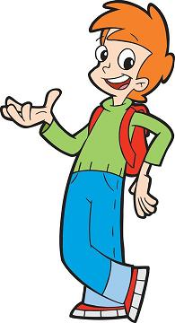

[This Photo](https://allthetropes.org/wiki/Cyberchase/Characters) by Unknown Author is licensed under [CC BY-SA](https://creativecommons.org/licenses/by-sa/3.0/)

How do you plan to make your game engaging?

I plan to make my game engaging by adding the function of earning points and using those points they can either buy something from our store that can be bought using that much points or convert it into e-money or converting it into gift cards or coupons.